Cybersecurity Incident Report:

Network Traffic Analysis

Scenario
Review the scenario below. Then complete the step-by-step instructions.
You are a cybersecurity analyst working at a company that specializes in providing IT consultant services. Several customers contacted your company to report that they were not able to access the company website www.yummyrecipesforme.com, and saw the error “destination port unreachable” after waiting for the page to load.
You are tasked with analyzing the situation and determining which network protocol was affected during this incident. To start, you visit the website and you also receive the error “destination port unreachable.” Next, you load your network analyzer tool, tcpdump, and load the webpage again. This time, you receive a lot of packets in your network analyzer. The analyzer shows that when you send UDP packets and receive an ICMP response returned to your host, the results contain an error message: “udp port 53 unreachable.”
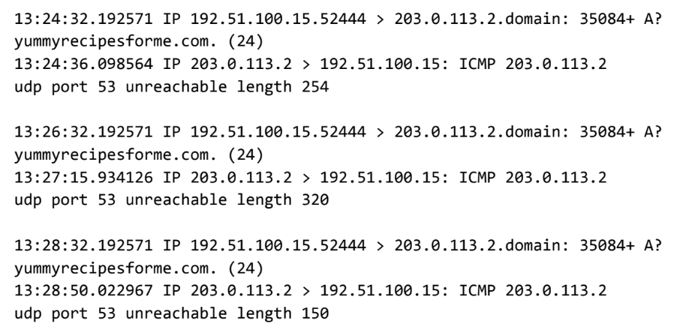

Network Traffic Analysis Incident Report
Part 1: Provide a summary of the problem found in the DNS and ICMP
traffic log.

The UDP protocol reveals that the DNS Server is down or unreachable. As evident by the results of the network analysis, the ICMP echo reply returned the error message “udp port 53 unreachable,” when attempting to access the company’s website, www.yummyrecipesforme.com. It is highly likely that the DNS server is not responding. The port 53 noted in the error message is the standard DNS port and it is used for communication between the DNS client and server. It is most likely that the DNS server is down, or a firewall is blocking Port 53. This may be an indication of Denial-of-Service attack or a misconfiguration.

Part 2: Explain your analysis of the data and provide at least one cause of the incident.
The Incident occurred in the afternoon at 1:24pm. The HR department was contacted by several customers who reported they were unable to access the company’s website. The report was forwarded to the IT department and the Network Security team was alerted.
When we received the report, the Network security team’s first action was to analyze and investigate the incident. We started by visiting the website which returned the same error message. We then proceeded to conduct a packet sniffing test using the network analyzer tool, Tcpdump to collect network data for analysis. The results presented in the logfile showed that when we send UDP packets and receive an ICMP response back to the host, an error message “udp port 53 unreachable.” is received. The UDS protocol was used to request a domain name resolution from the DNS server using the address of the DNS server over port 53. However, an error message was received indicating the ICMP Packets request send was undeliverable to the port of the DNS server, this means we were not able to obtain the IP address of the site www.yummyrecipesforme.com.

We are currently working on identifying whether the DNS Server is down or traffic to port 53 is blocked by the firewall. The DNS server might be down due a successful Denial of Service Attack or a misconfiguration.

